Từng bước nâng cấp prompt Game:
1 - Build a 3D game where you chop trees and collect logs.
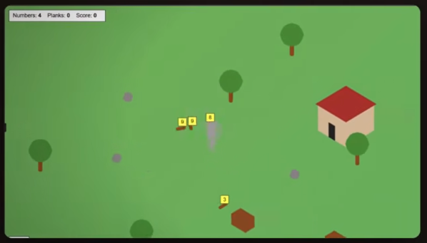
2 - Build a 3D low-poly lumberjack math game. Chop trees, collect numbered logs, then combine them with +, -, × at workbenches to hit target numbers. Cozy dark forest atmosphere, gold UI accents, Three.js with shadows and fog.
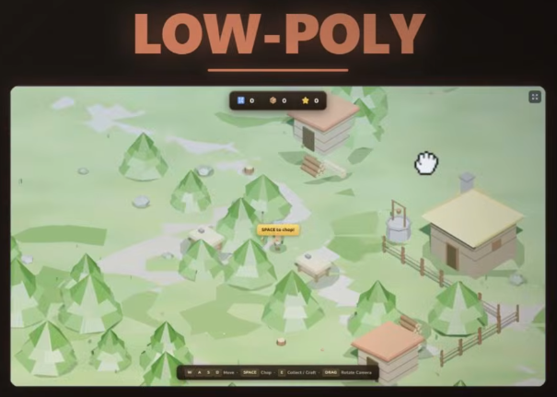
Tạo ra giao diện 3D sử dụng ít đa giác, mang lại vẻ ngoài tối giản và chuyên nghiệp.

Có thể thay thế:
Pixel art, voxel, và cell shaded.

3 - Build a 3D pixel art lumberjack math game. Chop trees, collect numbered logs, then combine them with +, -, × at workbenches to hit target numbers. Cozy dark forest atmosphere, gold UI accents, Three.js with shadows and fog.
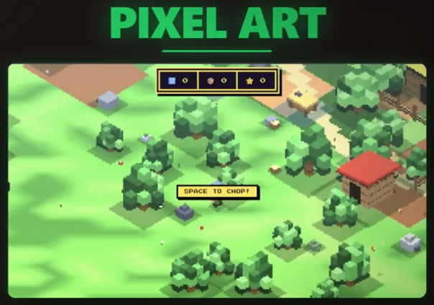
4 - Build a 3D voxel lumberjack math game. Chop trees, collect numbered logs, then combine them with +, -, × at workbenches to hit target numbers. Cozy dark forest atmosphere, gold UI accents, Three.js with shadows and fog.
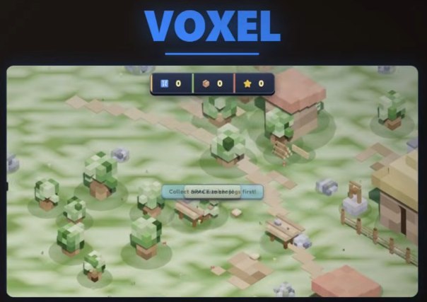
5 - Build a 3D cel-shaded lumberjack math game. Chop trees, collect numbered logs, then combine them with +, -, × at workbenches to hit target numbers. Cozy dark forest atmosphere, gold UI accents, Three.js with shadows and fog.
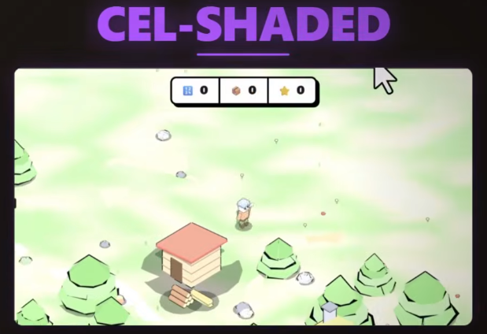
6 - Build a 3D flat shading lumberjack math game. Chop trees, collect numbered logs, then combine them with +, -, × at workbenches to hit target numbers. Cozy dark forest atmosphere, gold UI accents, Three.js with shadows and fog.
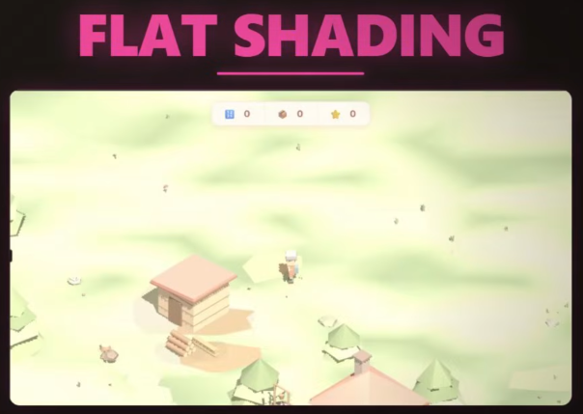
7 - Build a 3D isometric lumberjack math game. Chop trees, collect numbered logs, then combine them with +, -, × at workbenches to hit target numbers. Cozy dark forest atmosphere, gold UI accents, Three.js with shadows and fog.
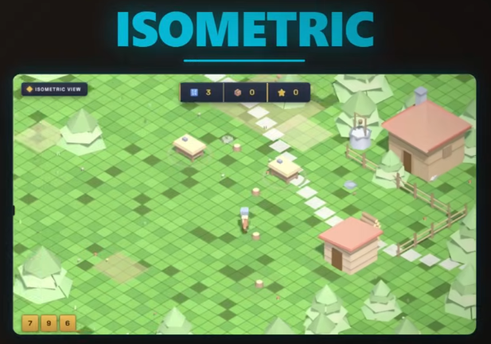
Góc nhìn từ trên xuống theo đường chéo, tạo cảm giác 3D trên không gian 2D.
Build game 3D + three.js:
- Runs in browser
- No installations
- No game engines
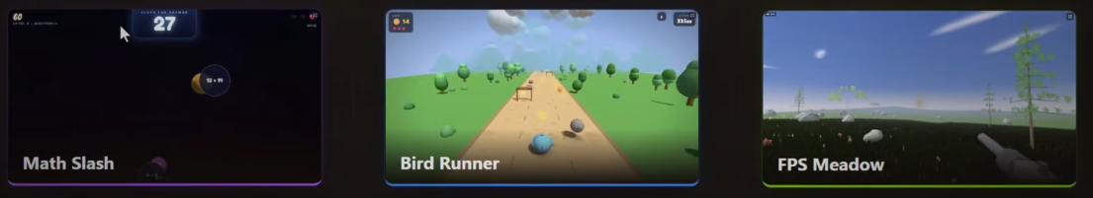
Mẫu để thay đổi:
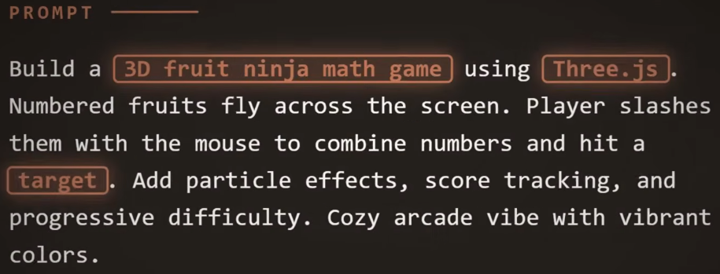
Build a 3D fruit ninja math game using Three.js. Numbered fruits fly across the screen. Player slashes them with the mouse to combine numbers and hit a target. Add particle effects, score tracking, and progressive difficulty. Cozy arcade vibe with vibrant colors.
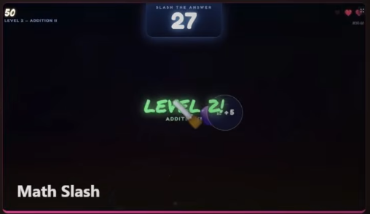

Biến game 2D từ ảnh tới 3D:
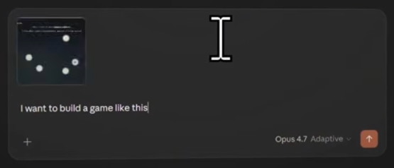
1 - I want to build a game like this
2 - lets make a new version, and lets update the game to be in 3d using ThreeJS
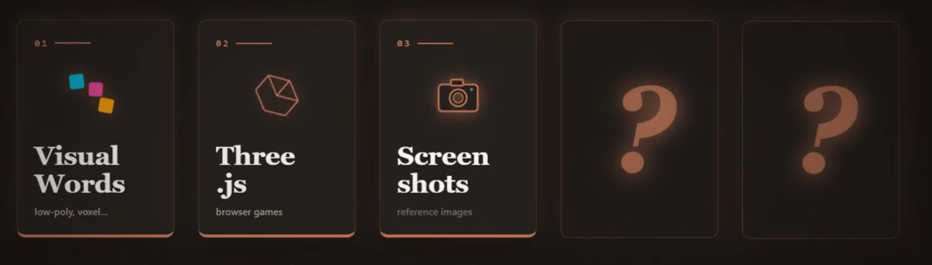
3/5
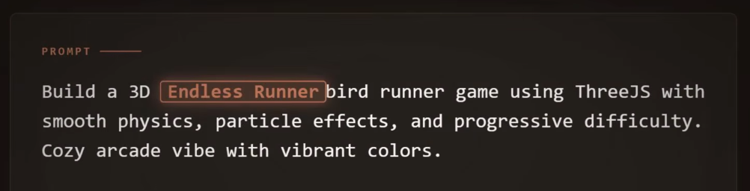
Build a 3D Endless Runner bird runner game using ThreeJS with smooth physics, particle effects, and progressive difficulty. Cozy arcade vibe with vibrant colors.
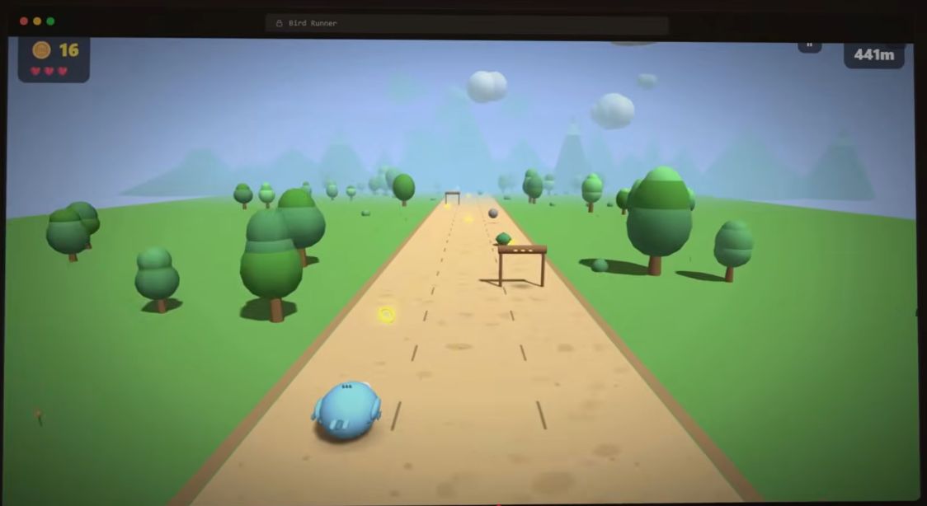
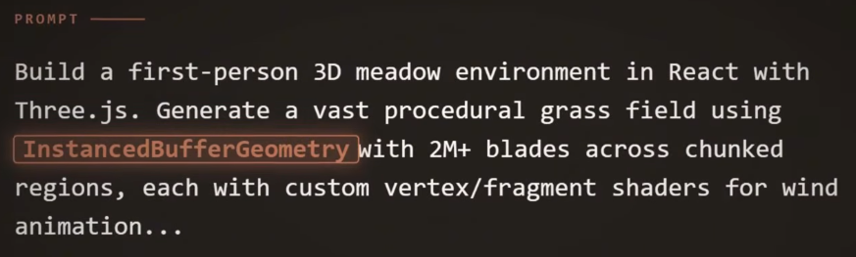
“Build a first-person 3D meadow environment in React with Three.js. Generate a vast procedural grass field using InstancedBufferGeometry with 2M+ blades across chunked regions, each with custom vertex/fragment shaders for wind animation...
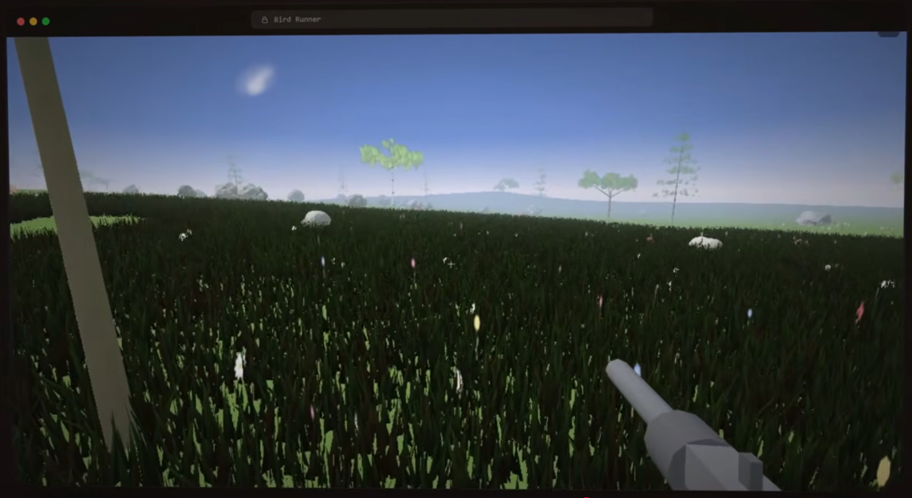
Ref: https://www.youtube.com/watch?v=Aj2LoQ8hcSQ

